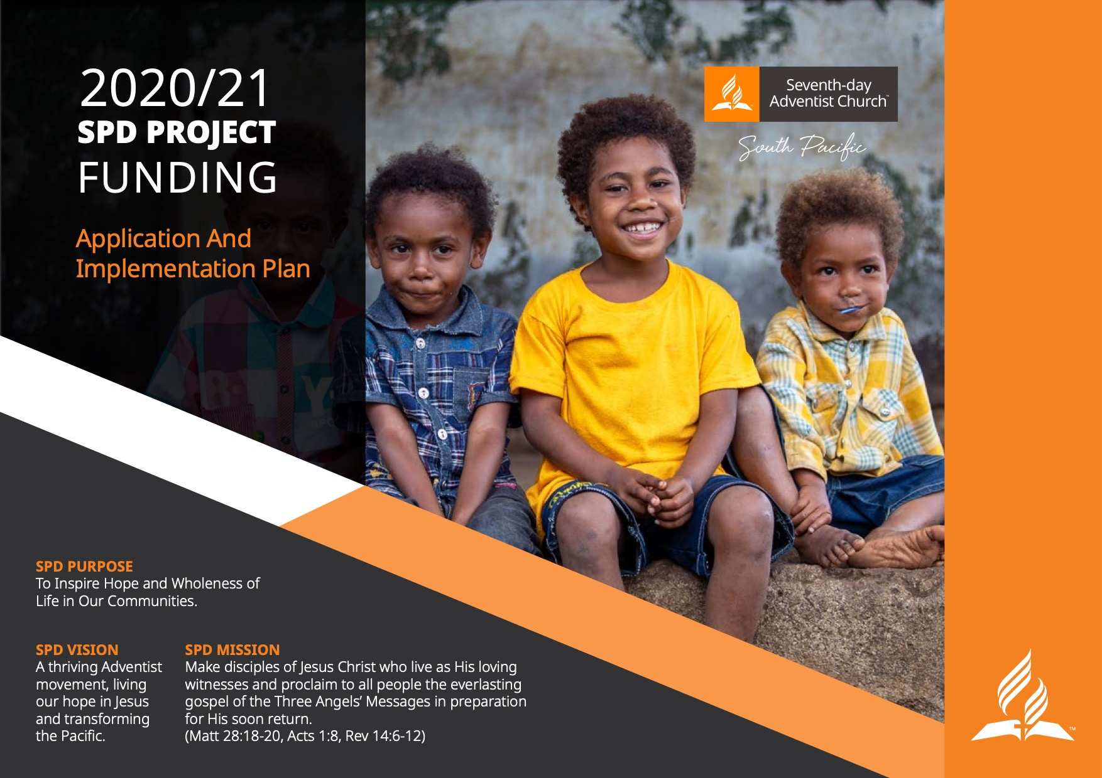

Project Name
Project Name:
<Mission/Conference to complete>
Name of Applying Entity:
<Mission/Conference to complete>
Project Sponsor:
<Mission/Conference to complete>
Union Approver:
<Union to complete>
SPD Arena Leader Consulted:
<Union to complete>
Proposed Project Manager:
<Union to complete>

Executive Summary
In no more than 3 sentences please describe your proposed project.

WHY? (Section 1 is about establishing why your ministry project should be funded)

The Opportunity
Please identify the opportunity for this project

Strategic Alignment
Please indicate how your project option fits in with the Division strategic focus areas listed in the appendix. E.g. A project by HopeChannel in Fiji could be to create programs in Hindi that are attractive to the Indian population. This type of project would fit very well in the Media space. Refer to Appendix for each of the Division Strategic Arena’s and their priority areas. No more than 3-4 sentences.

Assumptions/Constraints/Dependencies.
Consideration of the assumptions, constraints and dependencies is a key part of planning a project. Also include any dependencies on other projects being completed where necessary.

What Resources do you already have? (Assumptions)  List the things that you already have that will be used in the project. Eg. A project for TV/Radio content in Fiji might make the assumption that existing cameras will be suitable for the job. | What will limit your projects success? (Constraints)  List the things that will make it hard to work on your project. Eg. Broadcasters of TV/Radio programs often insist that programs are a particular length to fit in their schedule. This would be a constraint to the way the content is developed. | What does your project need from others? (Dependencies)  List the things you need from others or other projects to make your project successful. Eg. A project to create TV/radio content for broadcast will have a dependency that it is possible to secure a timeslot from a broadcaster. Please include any requirements for specialist skills, resources and/or consultants.

Organisational Capacity
Please explain how your organisation will manage and successfully implement the new project as part of everything else you are already doing.

Project Details
What do you need to make the project successful? (These are Inputs)  Some examples are money, employees, volunteers, equipment, digital tools, etc. | What does your project create or do for others? (These are Outputs)  Eg. 10,000 copies of a new brochure for members to distribute, a TV program that will play on TV, an evangelistic event attended by 1000 people. | What impact do you expect your project to have? (These are Outcomes)  All projects are expected to contribute to make some impact on the lives of those who receive the benefits of the project.

Project Finalisation and Review.
In this section please outline how the project will be evaluated during and after the project has finished. It can be useful to include references to the project outputs and outcomes identified earlier. While determining how a project will be evaluated it may be useful to consider 3 questions; What worked well? What could we improve? What new thing could we try?

Plans beyond the project funding horizon.
Please outline your plans for sustainability of the project once the Division funds have been used up. (Once the project funding runs out what happens?)

HOW? - Project Implementation Schedule

In this section please outline the broad steps you will take to bring your project to a successful conclusion – these are sometimes referred to as project milestones. To achieve a milestone usually takes a number of tasks and subtasks, include these where appropriate to provide extra context and detail for each milestone. Please include a Due Date for each milestone. Please put each milestone in a new row by adding rows as necessary.

Milestones - the key steps to deliver the project.  Use a single word or a short sentence to describe each step.  Eg. Planning People | Description/Notes  Enter any descriptive notes for each step.  Eg During the planning stage we will organise all the volunteers into teams and train them. | Start Date  Enter the start date for each step.  Eg. Beginning May 2020. | Due Date  Enter the due date for each step.  Eg. End of July 2020. | WHO  Who is responsible

Project Finance

Summary of Funding Sources (Over the life of the project)
Please copy from the excel spreadsheet below the summary figures for the project budget.

 | Local Church Contribution | Conf/Mission Contribution | Union Contribution | Division Contribution | GC funding | Other funding sources | Total Funding
Project contributions in Local Currency:
Project Contributions in Union Currency:(FJD/NZD/PGK)
Project Contributions in $AUD:

Detailed Budget
Please complete a separate detailed budget spreadsheet for each year of the project. Your detailed budget together with this document will form your project application. Applications without a detailed budget will not be considered. A template excel document is available as a separate attachment.

Project Standards and Progress Reporting obligations.

External Conduct standards.
The following information is included as Australian Charities must comply with these standards when providing funds to external organisations, particularly overseas entities. More information can be found here. (https://www.acnc.gov.au/for-charities/manage-your-charity/governance-hub/acnc-external-conduct-standards )

Standard 1 – Activities and Control of resources
This standard requires an Australian Charity to take reasonable steps to ensure that the projects being funded overseas are consistent with the charitable purpose of the Australian entity and that money is used in an appropriate way

Standard 2 – Annual review of overseas activities and record keeping.
This standard requires an Australian Charity to keep a record of its activities overseas.

Standard 3 – Anti Fraud and Anti Corruption
This standard requires an Australian Charity to minimise the possibility that the funds will be used in a corrupt way and that conflicts of interest are managed appropriately.

Standard 4 – Protection of vulnerable people
This standard requires an Australian Charity to take reasonable steps to ensure the safety of vulnerable people – including children.

Protecting children and Vulnerable people
Please outline how you will ensure that your project activities are delivered in a way the protects children and other vulnerable people from situations of abuse.
- In Australia and NZ - you will need to outline how you will comply with Adsafe policy and recommended guidelines for situations that may involve children and vulnerable people.
- In the Pacific – you will need to outline how you will address the concerns related to the situations with children and vulnerable people. If in doubt please contact your appropriate Union, SPD Office or Adsafe for advice and recommended guidelines.

Protecting against all forms of Fraud.
Please outline how you will ensure that use of project funds are not used in fraudulent and corrupt ways.

Property Insurance.
If your project application includes funding of larger capital items please note that the Division Finance Committee will not approve the new project unless the applying entity can demonstrate current insurance policies covering existing property assets.

Progress Reporting Expectations.
Projects that receive funding from the SPD will be expected to report on the project status 2 times per year using the standard reporting templates as a minimum. These reports are an important accountability for the funds that are allocated to your project.
The first report will be due at the end of the 6th month after the funding is available and then each 6months after that.

PLEASE NOTE - Failure to provide the first report on time will lead to a reminder being issued by the SPD and failure to provide a second report at the 12month interval will result in the funding being withdrawn. It is the project owners responsibility to ensure that project status reports are provided to the SPD Director of Programs and Strategic projects on time.

DECLARATION

The following undertaking is made by an authorised officer of (Name of Applicant Entity).

I, (authorised officer),

(Position) , submit this proposal and covenant to use all funds for the purposes for which they are provided, and to submit a written report within 90 days of the project completion date (provided above) that addresses the outputs, outcomes, and key performance indicators listed above.

In addition to the use of funds and reporting requirements, I agree and have verified, that where this project includes working with children and other vulnerable people the applicant can demonstrate knowledge of, and compliance with, Adsafe policies and recommended guidelines for such situations. (Please contact Adsafe directly if you need information on the policy and guidelines.)

Signature:

Date:

Appendices

SPD Strategic Focus Areas.
Below are the key Division strategic focus areas and their respective Big Rock strategies. These will be helpful as you consider the alignment of your project application with the Division priorities.

Discipleship (Refer to Leigh Rice for more information)
- Strengthening Healthy Churches
- Effective Training and Mobilisation
- Invest in the next Generation

Media (Refer to Brad Kemp for more information)
- Develop content and infrastructure so that HopeChannel TV/Faith FM/Hope Radio/HopeChannel.com though partnerships with each Union, become a significant source of new contacts for Local Churches.
- Equip and resource members to be part of personal disciple making activities by using new and existing content and new software tools.
- Build the brand equity and public perception of the Seventh-day Adventist Church - particularly focusing on Australia and New Zealand.

Health (Refer to Geraldine Przybylko for information)
- Promote the Health message to Leadership and Church through the Live More project.
- Create a blended ministry Discipleship movement.
- Build a branded Digital ecosystem that educates, inspires and promotes our Adventist Health philosophy.
- Create advocates for Adventist Health philosophy and grow the Adventist Health Network.

Mission to Cities (Refer to Wayne Krause for more information)
- Research for and Validation of initiatives/projects.
- Resource mission volunteerism.
- Develop streams of discipleship/church planting initiatives that come from the above.

